Speed Problems
Distance
Speed
Time
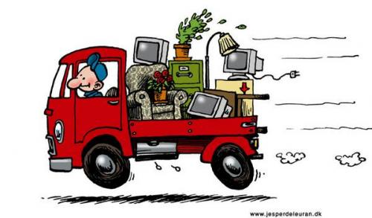

- A car travels 400m in 20s. Calculate the average speed of the car in m/s.
- A cyclist travels 30km in 12 minutes. Calculate the average speed in km/min.
- A train is travelling at 10m/s. How far does the train travel in 5 seconds?
- A car is travelling at 15m/s. How long does it take for the car to travel 600m?
- A bus is travelling at 40km/h. How long does it take for the bus to travel 72km?
- A trolley travels 20 metres in 1.5 seconds. What is its average speed?
- A model car travels at 2.5 m/s for 5 seconds. How far does the car travel?
- On the weekend, Barry goes for a bike ride. He travels 30km in 30 minutes. Calculate Barry’s speed in km/h.
- Tim’s car is travelling at 50km/h. How long does it take him to travel 20 km?
- Barry walks to Scott’s house, a distance of 600m in 5 minutes, but Scott is not home. Barry then walks to John’s house, 300m away and it takes him 3 minutes.
  - What was the total distance Barry walked?
  - How long did Barry’s walk take?
  - Calculate Barry’s average speed in m/min.
- A plane flies 420km in 1 hour 30 minutes. Find its average speed in km/h.
- A train travels 510m in a time of 17s. Calculate the average speed of the train in m/s.
- A boat sails 1.2km due east for a time of 5 minutes. Find the average speed of the boat in km/min.
- An aeroplane flies with an average speed of 85m/s for 20 s. Calculate the distance the aeroplane flies.
- A lorry travels along a straight road with a constant speed of 30m/s. After a time of 15 s, how far has the lorry travelled?
- Australia IV sails in a straight line from one buoy to the next. If the average speed is 4.8km/h and the time taken is 45 minutes, find the distance between the two buoys.
- Beth rides her horse 3km east and then 4km north. The trip takes her 30 minutes.
  - What is the total distance Beth travelled?
  - What is her average speed in km/h?
- Amanda drives her car 35km north and then 75km south in a time of 2 hours.
  - What is the total distance she travelled?
  - What is her average speed in km/h?
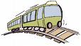
- A plane flies east at 250km/h for 3 hours and then south at 200km/h for 1 hour.
  - What is the total distance travelled?
  - What is the average speed in km/h?
- A train travels in a straight line from one station to the next at 40km/h and then returns at 60km/h. If the two stations are 5km apart, how long is the train’s journey?

Challenge
Do you remember the fable of the hare and the tortoise? The giant tortoise can reach a speed of about 7.5cm/s. A hare can run as fast as 20m/s. If their race was 1km long, how long was the hare asleep if the race resulted in a tie?

